**1. Exercise :** *5* **2. Date :** *05th November, 2020*

**3. Title :** Projection of solids.

**4. Aim :** To draw the orthographic multi-view projection of solid prisms/ cylinders/

pyramids/ cones.

**5. Software used :** *AutoDesk AUTOCAD 2021.*

**6. Introduction :**

**i. Prisms and Cylinders:**

*A prism is a 3-dimensional shape with two identical shapes facing each other. These identical shapes are called “bases”. The bases can be a triangle, square, rectangle or any other polygon. Other faces of a prism are parallelograms or rectangles.*

*A cylinder is one of the most basic curved geometric shapes, with the surface formed by the points at a fixed distance from a given line segment, known as the axis of the cylinder. The shape can be thought of as a circular prism. Both the surface and the solid shape created inside can be called a cylinder.*

………………………………………………………………………………………………………………………………………..

6.1 Terminology (pyramid with sketch): 6.2 Real time example - Picture

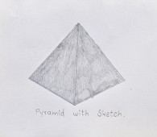 

Fig. Fig.

**7. Procedure** (for solving question):

**7.1** Question Outline : *To understand the fundamentals of projection of Solid*

*Prisms/ Cylinders/ Pyramids/ Cones.*

**7.2** Object : *Different types of Prisms, Polygons, etc.*

**7.3** Resting on Conditions : *Look whether the solid is resting on V.P. or H.P.*

**7.4** Other resting conditions (if any) : *Also, see the inclinations of solid with*

*respect to the axis.*

**7.5** Other conditions (if any) : *All dimensions should be in millimeters (mm).*

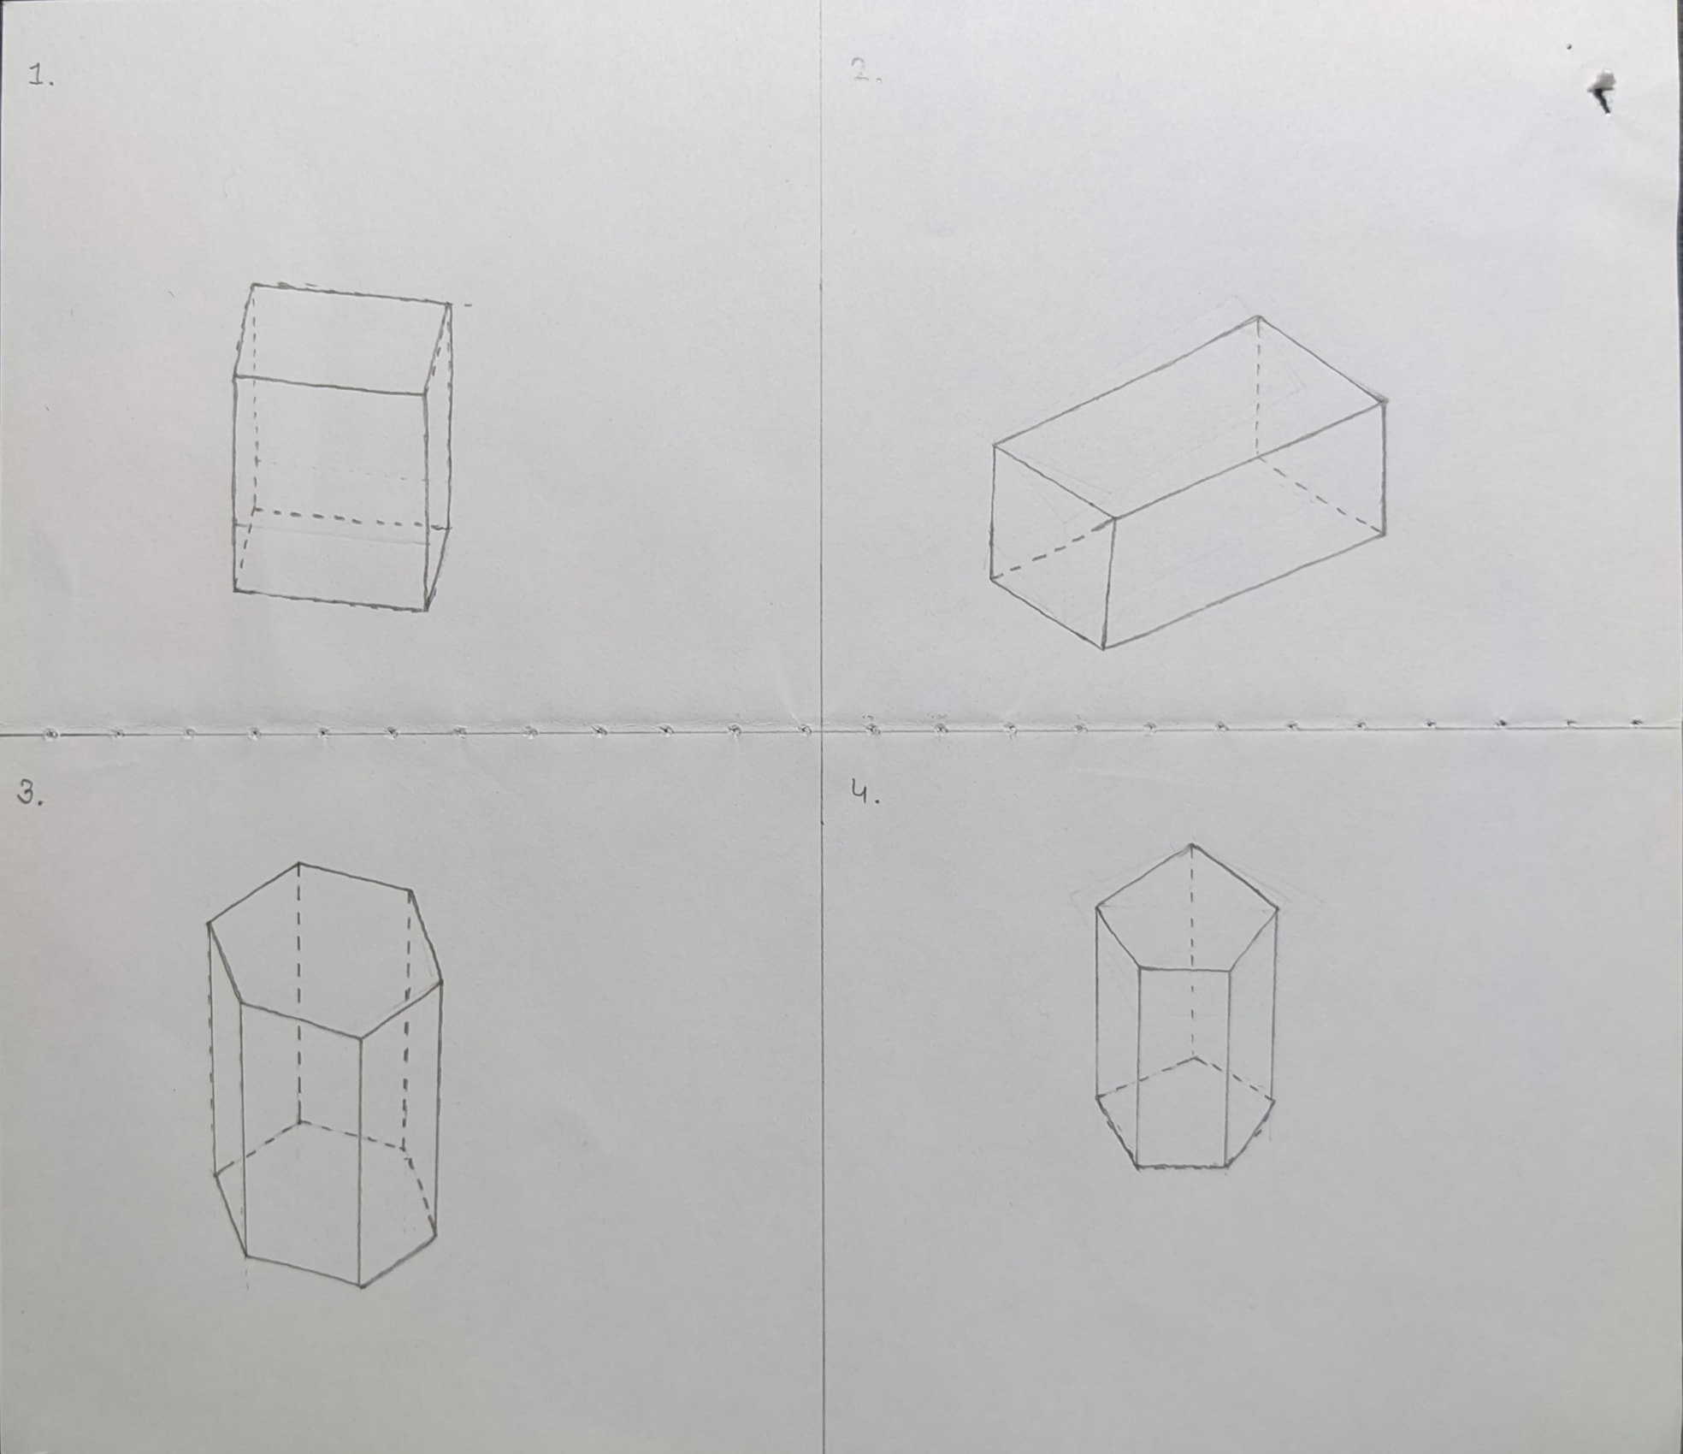

**Fig.: Free hand sketch of the solution to question**

**7.6** Drawing Procedure :

**Step 1. *Setting up the workspace :-***

* 1. *Set the units and precision we are going to work with using the* ***“UNITS”*** *command, here we will keep precision to be 1unit place (0) and unit as millimeter.*
  2. *Then, set the workable area using* ***“LIMITS”*** *command to area of (297mm) x (210mm) by specifying origin or lower left corner as (0, 0) and upper right corner as (297, 210).*
  3. *Finally, use the command* ***“ZOOM”*** *with the* ***“all”*** *attribute to expand the work area to the entire screen.*
  4. *From the “****workspace switching”*** *menu, available at bottom right corner, choose the “****3D Modelling workspace”*** *to draw the solids as instructed. Also, prefer using the different views so it will be easy to construct the solid (available in top left corner of the window).*
  5. *Also select* ***“First angle Projection”*** *available in the* ***View*** *menu in the* ***RIBBON****.*
  6. *Use the command* ***“LINE”*** *to make the XY axis.*

**Step 2. *Drawing a Cube :-***

* 1. *Make a square of 40mm by drawing the lines using the* ***“LINE”*** *command.*
  2. *Rotate the box 40 ° using the* ***“ROTATE”*** *command.*
  3. *Using the command “****VIEWBASE”*** *view the polygon in base view from model space.*
  4. *Mark the front, top, side view of the polygon in the base view.*
  5. *Draw the axis and show that the square has been rotated by 40°.*

**Step 3. *Drawing a Square Prism :-***

* 1. *Use the command* ***“BOX”*** *to start making the required square prism as follows.*
  2. *Select the starting point.*
  3. *Select the* ***length*** *method.*
  4. *Specify the required dimensions i.e.*
     + ***Length*** *= 60 units;*
     + ***Width*** *= 35 units;*
     + ***Height*** *= 35 units;*
  5. *Using the command* ***“VIEWBASE”*** *with the attribute* ***“MODEL SPACE”****,**draw the different views (Front view, Top view and side view) of the model in a blank layout.*
  6. *In the layout mark and annotate as required.*

**Step 4. *Drawing a Hexagonal Prism :-***

* 1. *Draw a polygon of six (6) sides using* ***“POLYGON”*** *command so it will be a hexagon of base of side measuring 30mm in* ***TOP*** *view.*
  2. *By switching into the views mentioned in point (setting up workspace) move to the* ***FRONT*** *view & extrude the entire hexagon using* ***“EXTRUDE”*** *command up to 60 mm as it is the axis length.*
  3. *Now, move from* ***2D-WIREFRAME*** *view to* ***CONCEPTUAL*** *view as it gives actual appearance of the solid (i.e. Hexagonal Prism).*
  4. *Click on* ***VIEW*** *available in* ***RIBBON*** *& select option Model Space then select the object to be redirected.*
  5. *Using this option, AUTOCAD redirects to the Layout page where one can project solids in top, front, side views respectively.*
  6. *Using the* ***“TEXT”*** *command, name the necessary terms if required (i.e. Front view, Top view, Side view, etc.).*
  7. *Measure the sides of the hexagon (Top view), rectangle (Front & Side view) using the* ***“DIMENSION”*** *command.*
  8. *Also,* ***“DIMSTYLE”*** *command can be used to set the size of arrows & text of dimensions.*
  9. *Join the top vertex & bottom vertex diagonally of hexagonal prism by drawing a line using the* ***“LINE”*** *command so as to get the longest diagonal*.

**Step 5. *Drawing a Pentagonal Prism :-***

* + - 1. *Make a polygon of edge 20mm using the* ***“POLYGON”*** *command.*
      2. *Rotate the polygon by 30 degrees using the* ***“ROTATE”*** *command.*
      3. *Extrude the polygon by 35 mm using the* ***“EXTRUDE”*** *command.*
      4. *View the polygon in base view from model space.*
      5. *Mark the front, top, side view of the polygon in the base view.*
      6. *Mark the XY axis and the front, top and side views using* ***“TEXT”*** *command.*
      7. *Mark the dimensions on the top view using* ***“DIMALIGNED”*** *and* ***“DIMANGULAR”*** *command.*

**Step 6. *Annotations :-***

* 1. *Using the command* ***“DIM”*** *and appropriate attributes mark all the dimensions taken in the experiment.*



**8. Commands Used :**

|  |  |  |
| --- | --- | --- |
| *Sr. No.* | *Command* | *Use* |
| ***1.*** | *UNITS* | *Used to set unit type and precision.* |
| ***2.*** | *LIMITS* | *Define the workspace and give it a boundary.* |
| ***3.*** | *ZOOM* | *Expand/contract the work area to the visible screen.* |
| ***4.*** | *LINE* | *Used to draw lines.* |
| ***5.*** | *DIMSTYLE* | *Used to change the look of the dimensions.* |
| ***6.*** | *STYLE* | *Used to change the way the text looks.* |
| ***7.*** | *TEXT* | *To write text in the Autocad file.* |
| ***8.*** | *ROTATE* | *Used to rotate the solid according to the given angle.* |
| ***9.*** | *POLYGON* | *Used to draw polygon of ‘n’ sides.* |
| ***10.*** | *DIMENSION* | *Used to measure the sides, angle, etc.* |
| ***11.*** | *EXTRUDE* | *Creates a 3D solid from an object that encloses an area.* |
| ***12.*** | *TRIM* | *Used to remove/erase any undesired line.* |
| ***13.*** | *BOX* | *Used to make a cube or cuboid.* |
| ***14.*** | *VIEWBASE* | *Used to change views from top to side to front, etc.* |
| ***15.*** | *DIM* | *Used to write the dimension of the objects.* |

**9. Result :**

*Thus, by the use of AutoCAD 2021 we are able to draw the solids respective of given length and also according to given inclinations. True length & Projected length can also be determined.*

|  |  |  |  |
| --- | --- | --- | --- |
| **Faculty Name** |  | **Date of Submission** |  |
| **Signature** |  | **Marks** |  |